Tutorial 5
- Describe with the aid of a suitable diagram the Ethernet II frame format.
- Describe with the aid of a suitable diagram the IEEE 802.3 frame format.
- Given the Wireshark frame dump in Figure 1, determine the following:
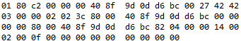
Figure 1 Wireshark frame dump 1
- The destination MAC address.
- Is the destination MAC address unicast, multicast, or broadcast?
- The source MAC address.
- Is the frame IEEE 802.3 or Ethernet II? Hence determine the length or the upper layer protocol.
- Given the Wireshark frame dump in Figure 2, determine the following:
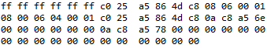
Figure 2 Wireshark frame dump 2
- The destination MAC address.
- Is the destination MAC address unicast, multicast, or broadcast?
- The source MAC address.
- Is the frame IEEE 802.3 or Ethernet II? Hence determine the length or the upper layer protocol.
- Given the Wireshark frame dump in Figure 1, determine the following:
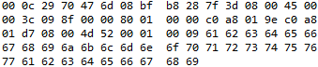
Figure 3 Wireshark frame dump 3
- The destination MAC address.
- Is the destination MAC address unicast, multicast, or broadcast?
- The source MAC address.
- Is the frame IEEE 802.3 or Ethernet II? Hence determine the length or the upper layer protocol.
- Describe the operation of CSMA/CD
- Determine the amount of time required to send the smallest Ethernet in frame in Gigabit Ethernet.
- Determine the amount of time required to send the largest Ethernet in frame in Gigabit Ethernet.

